**Experiment No. 3.2**

**Student Name: Rishav Kumar UID: 22MCC20039**

**Branch: MCA - CCD Section/Group: MCD-1/ Grp A**

**Semester: III Date of Performance: 27th Oct 23**

**Subject Name: Business Analytics Subject Code: 22CAH-703**

1. **Aim/Overview of the practical:**

Implementation of report in Tableau

**2. Code for practical:**

**Opening a Tableau Worksheet**

It is essential to know the entire Tableau worksheet and its elements. A Tableau worksheet can be seen as a report canvas or editor, which contains all the tools and functionalities necessary for complete report creation using data.

**Listed below are all the essential elements in a typical Tableau sheet.**

* **Data Pane:** It displays all the available fields from the data sources connected to Tableau
* Dimensions Section: From this section, it is possible to access all the dimension type fields. E.g.: Order id, Category, Date, Region, City, Sub-category, etc

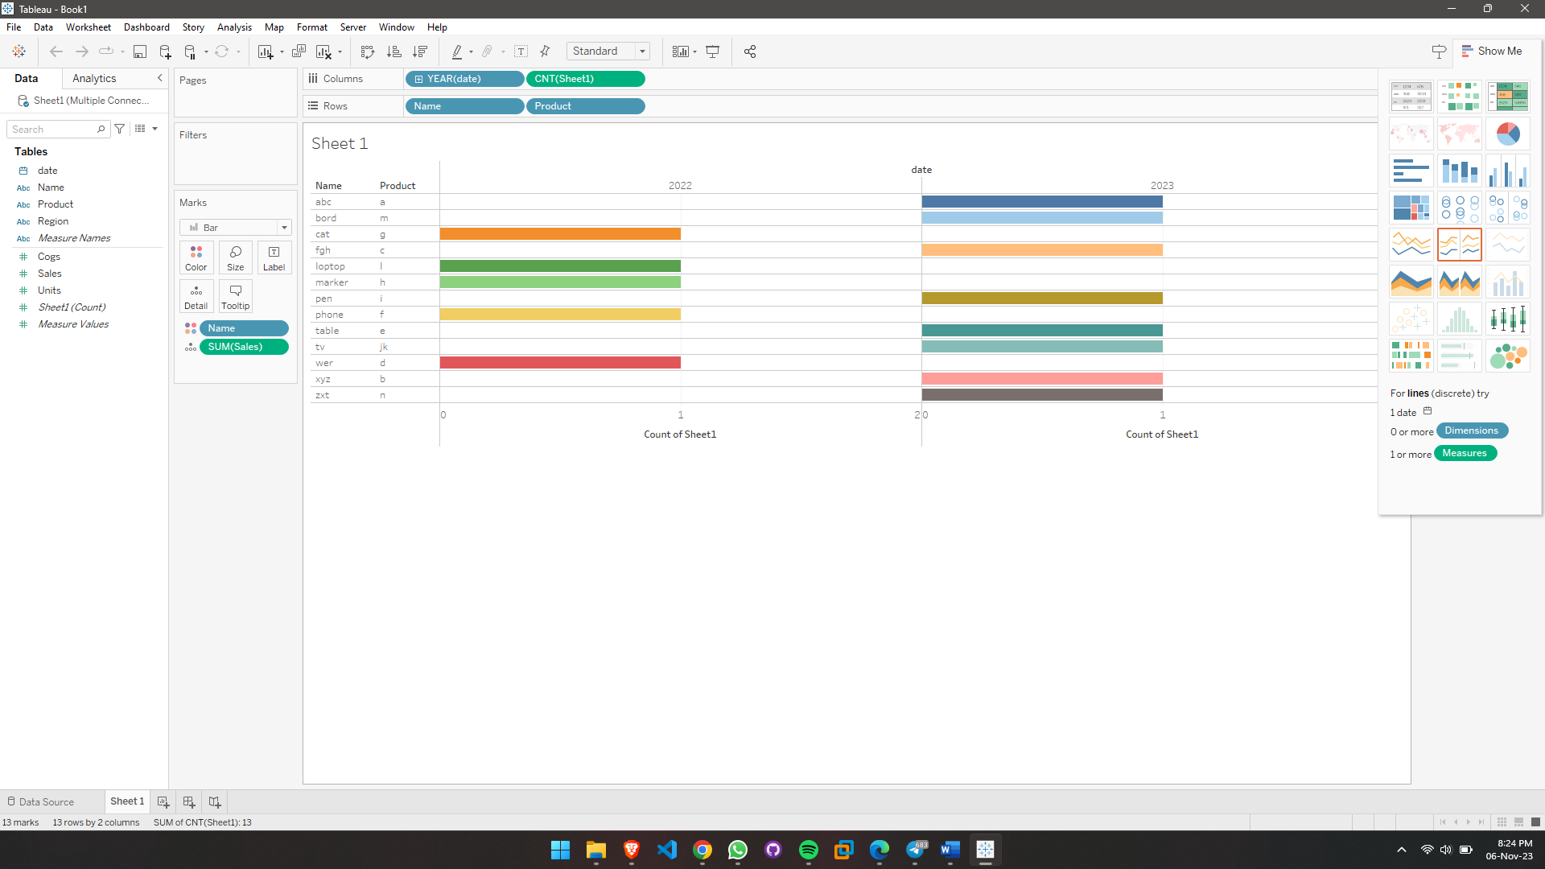

* **Measures Section:** It has got all the measure type fields (e.g., Quantity, Profit, Loss, Sales, etc.)
* **Columns and Rows:** These sections are where one can drag and drop the required dimension or measure fields to create charts
* **Drag and Drop Area:** It is the area in the centre of the sheet where the visual or chart is created.
* **Marks:** This section has useful tools that make the visuals detailed, presentable, and interactive. The panel has options like Size, Label, Text, Colour, Tooltip, etc. The visual can be customized as per preference from the options given.
* **Show Me:** This is a rack that has different kinds of visualizations (like charts and graphs) available in Tableau
* **Filters:** In this section, one can drag and drop fields and apply filters as per the requirements of the analysis
* **Pages:** Different fields can be placed in this section and Tableau will generate a report preview based on that
* **Data Sources:** From this page, one can handle data at the data source level by adding new data sources, editing the old ones, creating joins, etc.
* **Sheet:** This tab takes one to an active sheet and also allows its naming

**Adding Dimensions and Measures**

As per business requirements, create visualizations by dragging and dropping a field in the Rows or Columns section.

**Creating Visualization**

One can learn to create different visualizations in Tableau from the tutorials available in the Tableau tutorial package.

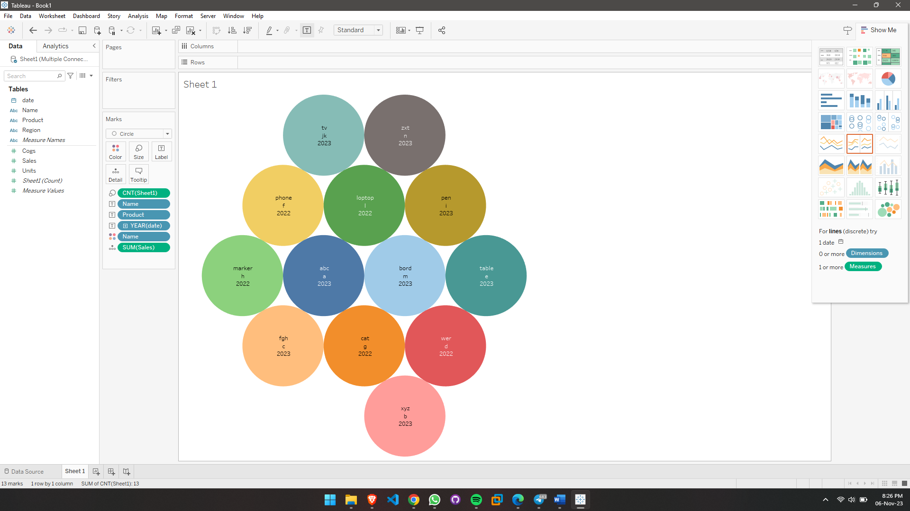

**Creating More Visualizations**

One can also create visualizations on separate sheets that can be combined together to create a report.

**Creating a Dashboard**

* Creating dashboards is the best way to represent data through the different visual elements in Tableau.
* Dashboards help to understand data and the story behind it through tables, graphs, maps, charts, and other visual objects.
* It is also possible to interact with the visuals through selection, filtering, and analysing the data trends.
* Create a new dashboard from the dashboard tab and add visuals to it by dragging and dropping them from the list provided in the Sheets section. After adding visuals, they can be adjusted on the dashboard as per requirements.

**Sharing a Dashboard as a Report**

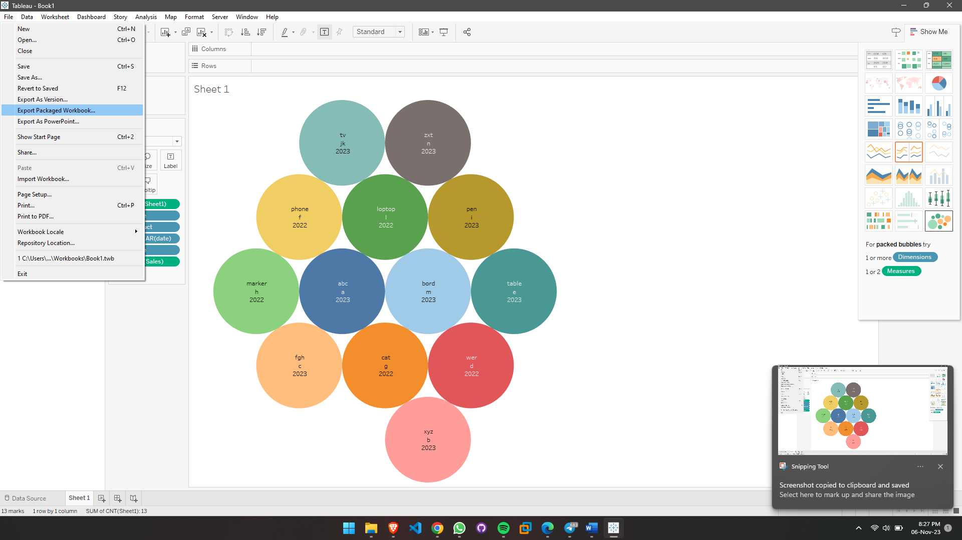

Once a dashboard is completed with all the required elements in order, it can be shared as a report with other users. The dashboard is also referred to as a workbook since it contains a collection of worksheets.

**************************************** **THE END** ***********************************************